News from the Board March 2024
Tēnā koutou katoa
It’s been a very busy start to the year. Our year 9s have had a week’s orientation prior to being joined by the rest of the school and I know the staff have enjoyed taking the time to get to know them. With more than 200 year nine students we have our largest intake in many years. As a board, we are mindful of the pressures on space and staff, and are anticipating the arrival of four new classrooms in Term 2. We are delighted to be able to continue government-supported school lunches, and we know how important it is that our akonga have a healthy food to fuel their learning. This term the staff are focussing on making learning, attendance and behaviour expectations clear. After consultation with our school community, we developed our phone policy, and this is also being implemented. We are mindful of the new government regulations so will adapt this policy as required for term 2.
At our first board meeting for the term we examined our NCEA results and strategic goals from 2023. We do this every year with a view to considering how we can lift achievement and provide the resourcing that our students and staff need to thrive. Our progress in relation to last year's strategic goals is reported in the Analysis of Variance document which is available on the school website. Our examination of academic achievement, reflections and feedback from staff, parents and whanau in 2023 has informed our latest strategic plan which will be in place for 2024-25 (also available on the website).
Our latest strategic plan has three main priorities: pedagogy (excellent teaching), student behaviour, and whakawhanaungatanga -building student resilience. Our annual goals reflect specific aspects of these broad strategic goals. This year, our annual goals are centred on providing professional development support for staff to be able to meet the diverse needs of students in their classrooms through culturally responsive and relational teaching and through designing lessons to ensure all students are extended in their learning. Our second annual goal involves ensuring staff provide an effective and consistent approach when managing and responding to student behaviour and our final goal for 2024 is to establish a facility (Te Toka) within the college to help meet the needs of students who struggle to attend classes due to well-being issues.
As is usual, as our February meeting was the board’s first meeting of the year we elected the chair and deputy chair (Garry Good). It was great to welcome back our other parent trustees for another year – Bob Slade, Megan Bolton, Alasdair Maclean, our co-opted representive Manuila Tausi, our student rep Irene Vehikite, our staff representative Chris Fearon and of course our tumuaki/principal, Mr Congdon. Kate Searle attends our meetings and does a tremendous job supporting us as board secretary. During our February meeting we also renewed membership of the various board committees we serve on (health and safety, property, discipline, and finance). I feel privileged to work with such a wonderful team of people and we look forward to all that 2024 brings.
Ngā mihi
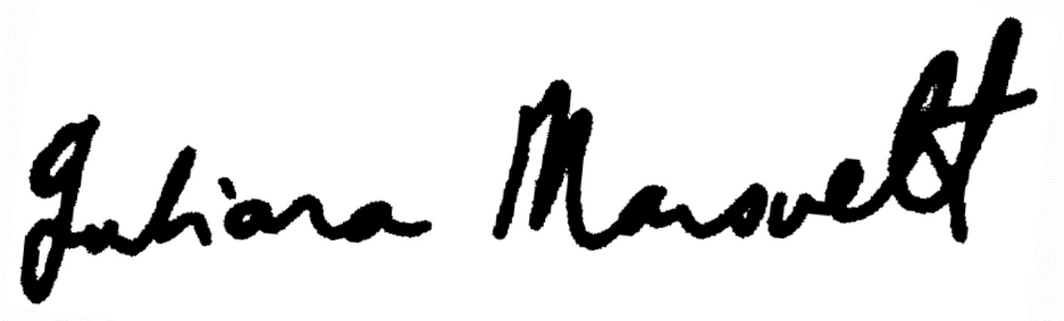
Juliana Mansvelt
Horowhenua College Presiding Member (Board Chair)

